|  |  |
| --- | --- |
| ***Name:*** | ***Sujal Sunil Nimje*** |
| ***Practical :*** | *8* |
| ***Practical Aim:*** | ***Practical Aim:***  *Write a Program to demonstrate the working of React Router library for Navigation in the Single Page Web applications..* |
| ***Section & Batch:*** | ***A3*** |

***Code:***

# Navbar.js

import React from 'react'

import React from "react";

import PropTypes from "prop-types";

import {Link } from "react-router-dom";

import About from "./About";

import TextForms from "./TextForms";

export default function Navbar(props) {

  return (

    <div>

      <nav className="navbar navbar-expand-lg bg-body-tertiary">

        <div className="container-fluid">

          <a className="navbar-brand" href="/">

            <b><i>{props.title.toUpperCase()}</i></b>

          </a>

          <button

            className="navbar-toggler"

            type="button"

            data-bs-toggle="collapse"

            data-bs-target="/navbarSupportedContent"

            aria-controls="navbarSupportedContent"

            aria-expanded="false"

            aria-label="Toggle navigation"

          >

            <span className="navbar-toggler-icon"></span>

          </button>

          <div className="collapse navbar-collapse" id="navbarSupportedContent">

              <ul className="navbar-nav me-auto mb-2 mb-lg-0">

                <li className="nav-item">

                  <Link className="nav-link active" aria-current="page" to="/">

                    Home

                  </Link>

                </li>

                <li className="nav-item">

                  <Link className="nav-link" to="/About">

                    Registration Form

                  </Link>

                </li>

                <li className="nav-item">

                  <Link className="nav-link" to="/Practical7">

                   Conditional Rendering

                  </Link>

                </li>

                <li className="nav-item">

                  <Link className="nav-link" to="/Counter">

                    Counter

                  </Link>

                </li>

                <li className="nav-item">

                  <Link className="nav-link" to="/Discount">

                    Discount Calculator

                  </Link>

                </li>

              </ul>

            <form className="d-flex" role="search">

              <input

                className="form-control me-2"

                type="search"

                placeholder="Search"

                aria-label="Search"

              />

              <button className="btn btn-primary" type="submit">

                Search

              </button>

            </form>

          </div>

        </div>

      </nav>

    </div>

  );

}

Navbar.propTypes = {

  title: PropTypes.string.isRequired,

};

Navbar.defaultProps = {

  title: "set title",

};

***TextForms.js***

import React, { useState } from "react";

export default function TextForms(props) {

  const [text, setText] = useState("");

  const handleUp = () => {

    console.log("Upper case was clicked");

    setText(text.toUpperCase());

  };

  const handleLow = () => {

    console.log("Lower case was clicked");

    setText(text.toLowerCase());

  };

  const handleOnchange = (event) => {

    console.log("onchange clicked");

    setText(event.target.value);

  };

  const clearText = () => {

    let con = window.confirm("you want to clear the entered text");

    if (con) {

      setText("");

    }

  };

  const [mystyle, setMystyle] = useState({

    color: "black",

    backgroundColor: "white",

  });

  const [btnname, setBtnname] = useState("Enable Dark Mode");

  const toggleStyle = () => {

    if (mystyle.backgroundColor === "white") {

      setMystyle({

        color: "white",

        backgroundColor: "black",

      });

      setBtnname("Enable Light Mode");

    } else {

      setMystyle({

        color: "black",

        backgroundColor: "white",

      });

      setBtnname("Enable Dark Mode");

    }

  };

  const speech = new SpeechSynthesisUtterance();

  function speak() {

    const message = text;

    speechSynthesis.lang = "en";

    speech.text = message;

    window.speechSynthesis.speak(speech)

  }

  return (

    <>

      <div className="container" style={mystyle}>

        <h2 className="my-3" style={mystyle}>

          {props.heading.toUpperCase()}

        </h2>

        <div className="input-group" style={mystyle}>

          <span className="input-group-text" style={mystyle}>

            Enter Text

          </span>

          <textarea

            style={mystyle}

            placeholder="Enter Text here..."

            value={text}

            onChange={handleOnchange}

            className="form-control"

            aria-label="With textarea"

            id="mytext"

          ></textarea>

        </div>

        <br />

        <button className="btn btn-primary mx-3" onClick={handleUp}>

          Convert to UpperCase

        </button>

        <button className="btn btn-primary mx-3" onClick={handleLow}>

          Convert to LowerCase

        </button>

        <button className="btn btn-primary mx-3" onClick={speak}>

          Text To Speech

        </button>

        <button className="btn btn-primary mx-3" onClick={toggleStyle}>

          {btnname}

        </button>

        <button className="btn btn-danger mx-3" onClick={clearText}>

          Clear Text

        </button>

      </div>

      <div className="container" style={mystyle}>

        <h2 style={mystyle} className="my-3">

          Your Text Details is Here...

        </h2>

        <p style={mystyle}>

          {text.split(" ").length} words and {text.length} characters is there

        </p>

      </div>

      <div className="container" style={mystyle}>

        <h2 style={mystyle} className="my-3">

         Preview

        </h2>

        <p style={mystyle}>

          {text}

        </p>

      </div>

    </>

  );

}

***Registration.js***

import React, { useState } from "react";

import "./StudentRegistration.css";

const StudentRegistration = () => {

  const [fname, setFname] = useState("");

  const [section, setSection] = useState("");

  const [cws, setCws] = useState();

  const [oops, setOops] = useState();

  const [math, setMath] = useState();

  const [physics, setPhysics] = useState();

  const [marks, setMarks] = useState();

  const [percent, setPercent] = useState();

  const handleSubmit = (e) => {

    e.preventDefault();

    let totalMarks =

      Number(cws) + Number(physics) + Number(oops) + Number(math);

    setMarks(totalMarks);

    setPercent(0.25 * totalMarks);

    console.log("This is the full information of Register Student!");

    console.log("First Name:" + fname);

    console.log("Last Name:" + section);

    console.log("cws:" + cws);

    console.log("your Mobile No = " + math);

    console.log("Roll No = " + oops);

    console.log("Password = " + physics + "\n");

  };

  // const resetTo = (e) =>{

  //   (e.preventDefault());

  // }

  return (

    <center>

      <div className="form">

        <form onSubmit={handleSubmit}>

          <h1>Student Score Card Calculating System</h1>

          <div style={{ margin: "15px" }}>

            <label>Name : </label>

            <input

              type="text"

              className="input"

              value={fname}

              onChange={(e) => setFname(e.target.value)}

            />

          </div>

          <div style={{ margin: "15px" }}>

            <label>Section : </label>

            <input

              type="text"

              className="input"

              value={section}

              onChange={(e) => setSection(e.target.value)}

            />

          </div>

            <h2>Enter the marks of Subject</h2>

          <div style={{ margin: "15px" }}>

            <label>CWS : </label>

            <input

              type="number"

              className="input"

              value={cws}

              onChange={(e) => setCws(e.target.value)}

            ></input>

          </div>

          <div style={{ margin: "15px" }}>

            <label>oops : </label>

            <input

              type="number"

              className="input"

              value={oops}

              onChange={(e) => setOops(e.target.value)}

            ></input>

          </div>

          <div style={{ margin: "15px" }}>

            <label>Maths : </label>

            <input

              type="number"

              className="input"

              value={math}

              onChange={(e) => setMath(e.target.value)}

            ></input>

          </div>

          <div style={{ margin: "15px" }}>

            <label>Physics : </label>

            <input

              type="number"

              className="input"

              value={physics}

              onChange={(e) => setPhysics(e.target.value)}

            ></input>

          </div>

          <h2>Calculate the Score</h2>

          <div>

            <p>Total Marks : {marks} </p>

            <p>Percentage : {percent} %</p>

          </div>

          <div style={{ marginTop: "15px" }}>

            <input type="submit" className="submit"></input>

          </div>

          <div style={{ marginTop: "15px" }}>

            <button

              type="reset"

              className="submit"

              style={{ backgroundColor: "red" }}

            >

              Reset

            </button>

          </div>

        </form>

      </div>

    </center>

  );

};

export default StudentRegistration;

***CosditionalRendering.js***

import React, { useState } from "react";

const Practical7 = (props) => {

  const [myInfo, setMyinfo] = useState({

    name: "",

    college: "",

  });

  const displayInfo = () => {

    if (window.confirm("you want to show your inforamation")) {

      setMyinfo({

        name: props.name,

        college: props.college,

      });

    }

    else{

      setMyinfo({

        name: "",

        college: ""

      });

    }

  };

  const { title, price, author } = { ...props.bookinfo };

  return (

    <div className="my-5">

      <center>

        <h1>

          MY Information : {title} {price} {author} {myInfo.name} {" "}

          {myInfo.college}

        </h1>

        <button className="btn btn-primary" onClick={displayInfo}>

          Show Info

        </button>

      </center>

    </div>

  );

};

export default Practical7;

***Counter.js***

import React, { Component } from 'react'

export default class Counter extends Component {

  constructor(props){

    super(props);

  }

    state = {count : 2}

    onIncreament(){

        this.state.count *= 2;

        this.setState(

            {

                count : this.state.count

            }

        )

        console.log(this.state.count)

    }

  render() {

    let style1 = {

      boxShadow: "0 4px 8px 0 rgba(0,0,0,0.2)",

      backgroundColor : "snow",

      color : "black",

      textAlign : "center",

      padding : "10px",

      margin : "20px",

      border : "none",

      borderRadius : "10px"

    }

    let style2 = {

      padding : "10px",

      margin : "0",

      backgroundColor : "green",

      borderRadius : "10px",

      color : "white",

      fontSize : "15px",

    }

    return (

      <div style={style1}>

        <h1>count = {this.state.count}</h1>

        <button style={style2} onClick = { ()=> this.onIncreament()}>Increament</button>

      </div>

    )

  }

}

***DiscountCalculator.js***

import React, { useState } from 'react'

const Discount = () => {

    const initialPrice = 3000;

    const[price, setPrice] = useState(initialPrice);

    function reset2 (){

        setPrice(initialPrice - 0.2 * initialPrice)

        console.log("jai shree RAM")

    }

  return (

    <div className='my-3'>

     <center>

     <h1>Oiriginal Price : {price} </h1>

      <button className='btn btn-primary mx-3 my-3' onClick={() => setPrice(initialPrice)}>reset</button>

      <button className='btn btn-primary mx-3 my-3' onClick={() => reset2()}>20% Discount</button>

      <button className='btn btn-primary mx-3 my-3' onClick={() => setPrice(initialPrice - 0.3 * initialPrice)}>30% Discount</button>

     </center>

    </div>

  )

}

export default Discount

***App.js***

import { BrowserRouter, Route, Routes } from "react-router-dom";

import "./App.css";

import Navbar from "./components/Navbar";

import TextForms from "./components/TextForms";

import StudentRegistration from "./components/StudentRegistration";

import Counter from "./components/counter";

import Discount from "./components/Discount";

import Practical7 from "./components/Practical7";

function App() {

  return (

    <div>

      <BrowserRouter>

      <Navbar title="my first website in react" />

        <div >

          <Routes>

            <Route exact path="/" element={<TextForms heading = "text enhancer"/>}></Route>

            <Route exact path="/about" element={<StudentRegistration />}></Route>

            <Route exact path="/Practical7" element={<Practical7 name = "sujal nimje" college = "RCOEM"/>}></Route>

            <Route exact path="/Counter" element={<Counter />}></Route>

            <Route exact path="/Discount" element={<Discount />}></Route>

          </Routes>

        </div>

      </BrowserRouter>

    </div>

  );

}

export default App;

***output :***

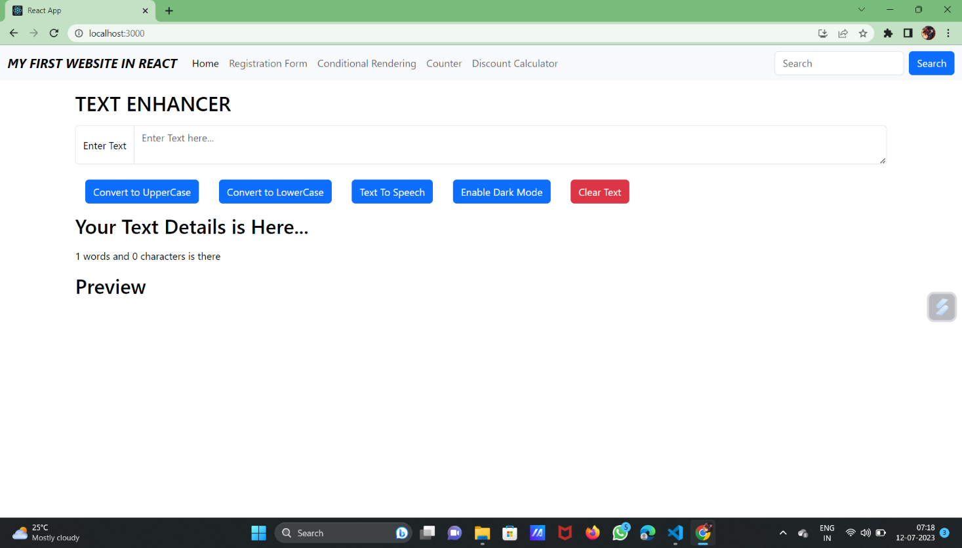

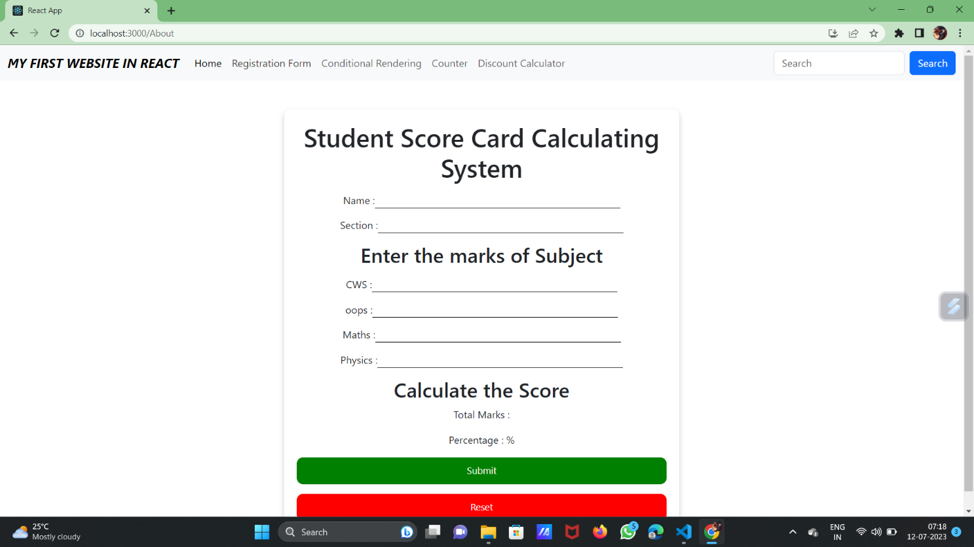

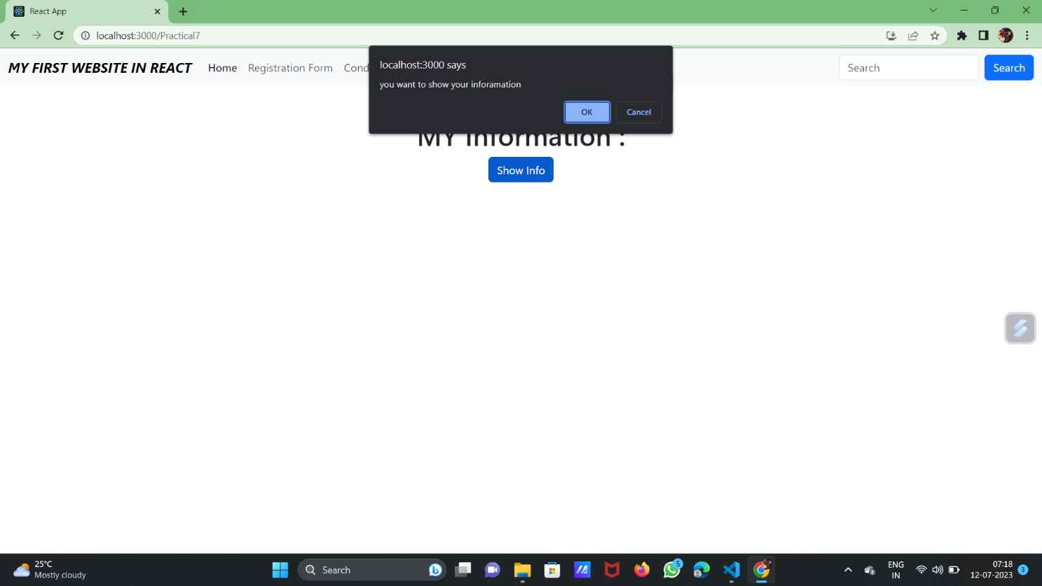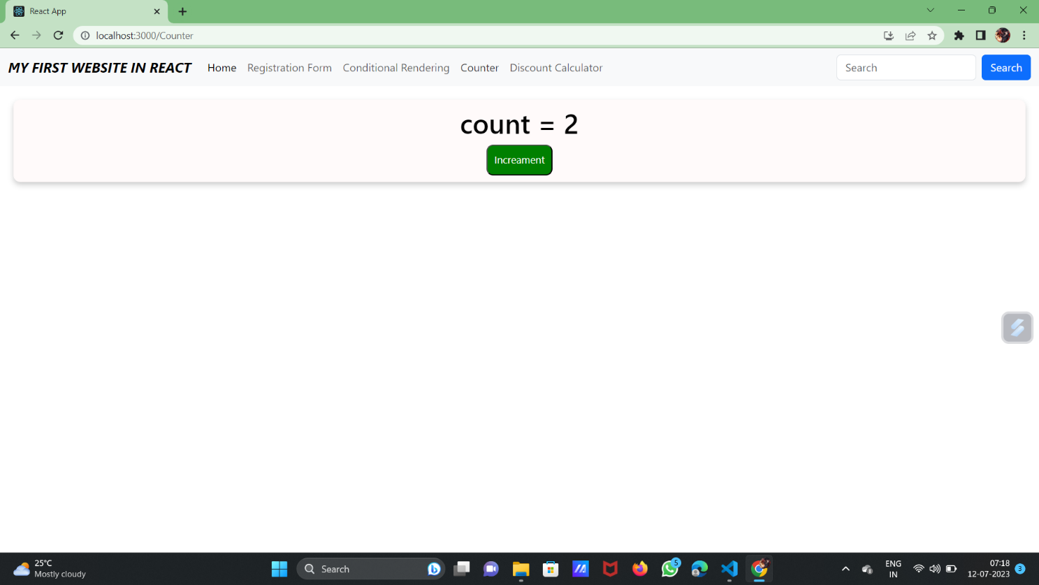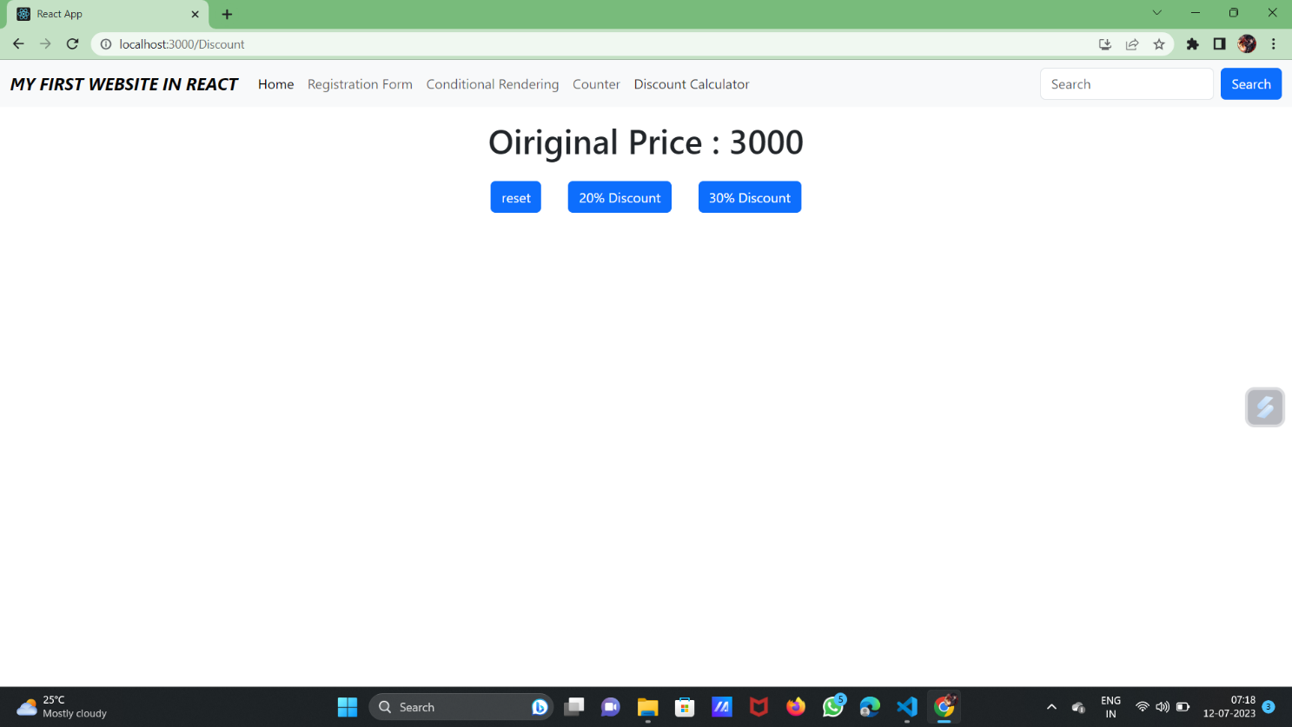

***Conclusion:*** *With this Practical I learnt about Router which is useful to navigate from one page to another page*